# Exercise Session 5 – Input Output Analysis

ENV–501 Material and Energy Flow Analysis

November 27, 2022

## Exercise 1: Primary energy and CO2 emissions from automobile parts

The aim of this exercise is to evaluate the environmental impacts associated with one part of a car. The front panel is a static piece (see Figure 1), which is used to keep other parts of the car together. It does not have any other mechanical function. A supplier to the automotive industry faces a decision regarding the choice of material for this new structural part. The development department of the company has selected three materials that could satisfy the functional and production requirements. The three materials selected are steel, aluminum and a thermoset composite (polyester-based sheet molding compound). As a first step, study in details the case of aluminum.

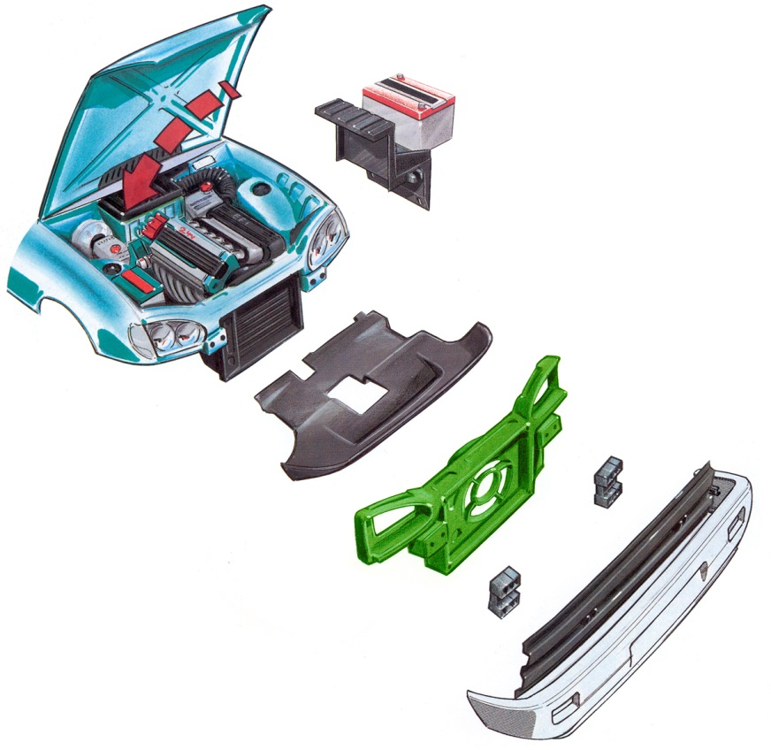

Figure 1: The front panel is the green part

To help with the decision making, this exercise evaluates the life cycle primary energy use and CO2 emissions of the aluminum front panel using a simplified Input-Output matrix. Its weight is 5.9 kg and it lasts for the average lifetime of an automobile or approximately 200’000 km. The amount of fuel specifically required to carry the front panel over this distance is 30.4 liters.

Input-Output and economic data

Input-Output tables are normally available at governmental bureau of statistics (for example the Bureau of Economy Analysis in the US). Table 1 presents a small extract of the monetary flows between the main sectors involved in the aluminum front panel production.

Table 1: Transaction matrix [M$] and total output [M$]

|  |  |  |  |  |  |
| --- | --- | --- | --- | --- | --- |
|  | **Aluminum** | **Coal & Petroleum** | **Electricity** |  | **Total output [M$]** |
| **Aluminum** | 976 | 0 | 0 |  | 5’688 |
| **Coal & Petroleum** | 0.50 | 5’877 | 13’240 |  | 109’680 |
| **Electricity** | 1’518 | 1'243 | 27 |  | 132’400 |

Questions:

1. Interpret the term 13’240 of the transaction matrix (table 1). What are the most important suppliers and customers for the aluminum sector (in monetary terms)?
2. Given the transaction matrix and the total output, complete the matrix of direct coefficients (A) and give an interpretation of its bottom row.

Environmental data

Table 2: Total primary non-renewable energy consumption and CO2 emission per sector per year

|  |  |  |
| --- | --- | --- |
| **Sector** | **Energy consumption [MJ/year]** | **CO2 emissions [kg/year]** |
| Aluminum | 0 | 1.1E9 |
| Coal & Petroleum | 6.26E13 | 76E9 |
| Electricity | 0 | 1.5E12 |

1. Using tables 1 and 2, calculate the environmental vectors for the primary energy consumption and for the CO2 emissions.

Case specific data:

1. To be able to evaluate the embodied energy and the CO2 emissions, case specific data has to be collected. Calculate the vector of final demand below.

Table 3: Aluminum front panel data and related prices

|  |  |  |  |
| --- | --- | --- | --- |
| Goods | Required amounts | Price | Final demand |
| Aluminum | 5.9 [kg/panel] | 2.5 [$/kg] |  |
| Oil for manufacturing | 2.14 [l/panel] | 0.32 [$/l] |  |
| Electricity for manufacturing | 15.2 [kWh/panel] | 0.07 [$/kWh] |  |
| Gasoline during the use phase | 30.4 [l/panel] | 0.36 [$/l] |  |

1. Using the data provided in table 3, determine the necessary final output (in monetary units) in each sector in order to manufacture one front panel. Identify the sector that generates the most important contribution to the final output of the electricity sector.
2. Estimate the total non-renewable primary energy consumption induced by the manufacturing of a front panel.
3. Calculate the contribution of tier 0, 1, 2 and 3 to the non-renewable primary energy consumption.
   1. Explain the high value found in tier 2.
   2. Are the contributions of the second and third tiers significant?
   3. Verify the convergence (decreasing contributions of higher tiers) between the value of non-renewable energy consumption and the value calculated in question 6.
4. Calculate the primary embodied energy of gasoline necessary over the product’s life cycle or approximately 200’000 km. What sector shows the biggest difference in final output when accounting for the gasoline necessary during the use phase?
5. Calculate the total CO2 emissions taking into account the gasoline necessary over the product’s life cycle or approximately 200’000 km.
6. Process MFA calculation resulted in an estimated 179 kg of CO2 for the aluminum front panel, explain the potential differences with the value found above.

## Exercise 2: Input output analysis of a simplified economy

Imagine an economy represented by 6 main activities linked by the monetary (in millions of CHF) transactions described in the table below.

|  |  |  |  |  |  |  |  |
| --- | --- | --- | --- | --- | --- | --- | --- |
|  | Agriculture | Extractive industries | Manufacturing | Electricity generation | Transportation | Services | Final demand |
| Agriculture | 10 | 0 | 10 | 0 | 0 | 0 | 40 |
| Extractive industries | 0 | 5 | 0 | 50 | 0 | 0 | 0 |
| Manufacturing | 20 | 20 | 20 | 10 | 30 | 0 | 40 |
| Electricity generation | 10 | 5 | 50 | 5 | 0 | 50 | 30 |
| Transportation | 5 | 10 | 20 | 0 | 20 | 20 | 10 |
| Services | 5 | 10 | 30 | 50 | 10 | 10 | 20 |
| Value added | 10 | 5 | 10 | 35 | 25 | 55 |  |
| Total inputs | 60 | 55 | 140 | 150 | 85 | 135 |  |

Questions:

1. What is the main input of the agricultural sector? In what proportion?
2. Which sector mainly buys products (goods and services) from the services sector? In what proportions?
3. What are the products for which extractive industries are used the most?
4. What can you say about the agricultural sector?
5. Which sector generates the most wealth in this economy?

Derive the total output of each sector and compute the matrix A of coefficients. The emission inventories for this economy summarize the CO2 emissions per sector below (in tons):

|  |  |
| --- | --- |
| Tons of CO2 | |
| Agriculture | 50 |
| Extractive industries | 60 |
| Manufacturing | 120 |
| Electricity generation | 200 |
| Transportation | 150 |
| Services | 20 |

1. Which sector produces the most CO2? In what proportions?
2. Which sector has the largest direct CO2 intensity? Which intensity?
3. Compare the direct, indirect and total emissions of CO2 in this economy.
   1. Suppose demand for products from company XYZ changes and its new bill of materials says that 2 mio CHF were spent on manufactured products, 1 mio CHF on transportation, and 1 mio CHF on electricity, what are the scope 1, 2, and 3 emissions of the company?
4. Calculate the contributions of tiers 0 to 6 for the tons of CO2 emissions in this simplified economy and the cumulative percentages with respect to the value calculated above.
   1. What can you say about the resulting curve?
   2. How do you explain the difference with the contribution by tier in exercise 1?